Bioinformatics Assignment on
Functional Genomics and Next Generation Sequencing Data analysis

Assignment-1 Variant Analysis Project (Choose a WGS/WES Dataset)
1. Identify a Whole Genome Sequencing (WGS) or Whole Exome Sequencing (WES) dataset from a public databases like SRA, GEO
If you want to find WES datasets like ERX11787512:
- Go to https://www.ncbi.nlm.nih.gov/sra
Type:
"whole exome sequencing" AND "Homo sapiens"[Organism]
- You’ll see many SRR IDs — look for:
  - Platform: Illumina
  - Size: Prefer < 5GB for easy download
  - BioProject/BioSample info

Dataset Selection
For this variant analysis project, I selected a publicly available Whole Exome Sequencing (WES) dataset from the NCBI Sequence Read Archive (SRA). The chosen dataset has the SRA/ENA Run ID ERX11787512, which is part of the Project ID PRJEB71772 / ERP156556 and associated with the sample type FFPE tumor tissue. The organism studied is Homo sapiens, and the sequencing was performed using the Illumina NovaSeq 6000.
The dataset was selected due to its manageable size and high-quality sequencing, making it ideal for academic variant analysis projects. It contains paired-end reads and uses the Whole Exome Sequencing (WXS) library strategy, which focuses on Whole exome sequencing of anaplastic thyroid cancer of Indian origin.

Summary of the Dataset (ERR12411154)
Attribute | Value
Run ID | ERR12411154
Study Title | WES of anaplastic thyroid cancer of indian origin
Organism | Homo sapiens
Platform | Illumina Novaseq 6000
Library Strategy | WES
Layout | Paired-end
Total Bases | 2.3G
Download Size | ~699.8MB
Sample Type | FFPE Tumor tissue
Project ID | PRJEB71772/ ERP156556
Run ID(SRA/ENA) | ERR12411154 on ENA
2. Download raw FASTQ files.
1.Install SRA Toolkit (For Downloading SRA Data)
sudo apt update && sudo apt install sra-toolkit
fastq-dump –version
prefetch ERR12411154 (downloading files from SRA)
krishnakavitapanwar@krishna:/mnt/c/Users/kavit$ prefetch ERR12411154 2025-07-16T07:37:48 prefetch.3.2.1: 1) Resolving 'ERR12411154'... 2025-07-16T07:37:54 prefetch.3.2.1: Current preference is set to retrieve SRA Normalized Format files with full base quality scores 2025-07-16T07:37:56 prefetch.3.2.1: 1) Downloading 'ERR12411154'... 2025-07-16T07:37:56 prefetch.3.2.1: SRA Normalized Format file is being retrieved 2025-07-16T07:37:56 prefetch.3.2.1: Downloading via HTTPS... 2025-07-16T07:37:56 prefetch.3.2.1: Continue download of 'ERR12411154' from 444216855 2025-07-16T07:40:21 prefetch.3.2.1: HTTPS download succeed 2025-07-16T07:40:29 prefetch.3.2.1: 'ERR12411154' is valid: 733806093 bytes were resumed from 444216855 2025-07-16T07:40:29 prefetch.3.2.1: 1) 'ERR12411154' was downloaded successfully 2025-07-16T07:40:29 prefetch.3.2.1: 1) Resolving 'ERR12411154's dependencies... 2025-07-16T07:40:29 prefetch.3.2.1: 'ERR12411154' has 0 unresolved dependencies
fasterq-dump --split-files ERR12411154
krishnakavitapanwar@krishna:/mnt/c/Users/kavit$ fasterq-dump --split-files /mnt/c/Users/kavit/ERR12411154/ERR12411154.sra --threads 4 spots read : 7,518,113 reads read : 15,036,226 reads written : 15,036,226
successfully extracted the FASTQ files from .sra file using fasterq-dump
- Install FastQC (For Quality Control)
sudo apt install fastqc
fastqc –version
fastqc -o QCresults ERR12411154_1.fastq,ERR12411154_2.fastq
krishnakavitapanwar@krishna:/mnt/c/Users/kavit$ find /mnt/c/Users/kavit/ -name "ERR12411154_*.fastq" find: ‘/mnt/c/Users/kavit/AppData/Local/Temp/WinSAT’: Permission denied /mnt/c/Users/kavit/ERR12411154_1.fastq /mnt/c/Users/kavit/ERR12411154_2.fastq
That output confirms:
- FASTQ files are successfully extracted
- They are located directly in:
/mnt/c/Users/kavit/
Click here to view the NGS html report (pdf version)
https://drive.google.com/file/d/1b1F2P2cSNtO1vD3mIWdOtfjsEM0ab7t_/view?usp=drive_link
 | https://drive.google.com/file/d/1bUm58fTs1PrYgmJ7j9olivUigmiLwkD9/view?usp=drive_link
- 1. Alignment to reference genome (e.g., BWA, STAR, or Hisat2) | ✅ FastQC Summary for ERR12411154 Reads  🔹 Read 1: ERR12411154_1.fastq  - Per base sequence quality: ✅ PASS  - Per tile sequence quality: ⚠️ WARNING (common in HiSeq/NovaSeq; usually not critical)  - Adapter content: ✅ PASS  - Overall: Good quality, no trimming needed for Reads  🔹 Read 2: ERR12411154_2.fastq  - Per base sequence quality: ✅ PASS  - Per tile sequence quality: ⚠️ WARNING (same reason as above)  - Adapter content: ✅ PASS  - Overall: Also good quality, no trimming needed  🔹 Why Trimming Was Not Performed  - After running FastQC on both paired-end FASTQ files (ERR12411154_1.fastq and ERR12411154_2.fastq), the quality assessment results indicated that trimming was not necessary.  Specifically:  - The Per Base Sequence Quality plots showed high-quality scores (mostly in the green zone), with no significant quality drop at the start or end of reads.  - The Adapter Content module did not flag any adapter contamination, indicating successful library preparation and sequencing.  - Although there was a “Per Tile Sequence Quality” warning, this is common with NovaSeq data and typically does not affect downstream variant calling.  - Alignment to reference genome  Align FASTQ Reads to the Human Reference Genome (hg38)  Step 1: Install Bowtie2  sudo apt update  sudo apt install bowtie2  What is a Reference Genome?  A reference genome is a standard, high-quality, complete DNA sequence for a species — like Homo sapiens (human).  You need it so that tools like BWA or Bowtie2 can:  - Compare your sample reads to the known genome  - Find where each read maps in the genome  - Detect differences (like SNPs or INDELs), which we call variants  Why Do We Need the Reference Genome?  In my WES dataset (ERR12411154), the reads are short DNA fragments from a real patient sample.  These short sequences don’t come with position labels — the aligner (BWA/Bowtie2) needs the reference genome to:  - Align reads to their correct positions.  - Help you find mutations or changes compared to the reference (for variant calling)  Without the reference, you can’t do alignment or variant detection.  The most common human reference is:  - hg38 (also called GRCh38)  - It’s the latest version of the human genome  Download from Ensembl in Browser  krishnakavitapanwar@krishna:/mnt/c/Users/kavit$ mv /mnt/c/Users/kavit/Downloads/Homo_sapiens.GRCh38.dna.primary_assembly.fa.gz . krishnakavitapanwar@krishna:/mnt/c/Users/kavit$ gunzip Homo_sapiens.GRCh38.dna.primary_assembly.fa.gz  Homo_sapiens.GRCh38.dna.primary_assembly.fa  This is the full human reference genome (Ensembl GRCh38), ready to use.  -rwxrwxrwx 1 krishnakavitapanwar ... 3.1G ... Homo_sapiens.GRCh38.dna.primary_assembly.fa  gunzip finished correctly  Step: Build Bowtie2 Index for the Reference Genome  bowtie2-build Homo_sapiens.GRCh38.dna.primary_assembly.fa GRCh38  krishnakavitapanwar@krishna:~/bowtie2_index$ wget https://genome-idx.s3.amazonaws.com/bt/GRCh38_noalt_as.zip --2025-07-16 20:57:13-- https://genome-idx.s3.amazonaws.com/bt/GRCh38_noalt_as.zip Resolving genome-idx.s3.amazonaws.com (genome-idx.s3.amazonaws.com)... 52.217.37.36, 3.5.28.110, 54.231.161.105, ... Connecting to genome-idx.s3.amazonaws.com (genome-idx.s3.amazonaws.com)|52.217.37.36|:443... connected. HTTP request sent, awaiting response... 200 OK Length: 3749239215 (3.5G) [application/zip] Saving to: ‘GRCh38_noalt_as.zip’ GRCh38_noalt_as.zip 100%[============================================================================>] 3.49G 2.60MB/s in 31m 53s 2025-07-16 21:29:08 (1.87 MB/s) - ‘GRCh38_noalt_as.zip’ saved [3749239215/3749239215]  krishnakavitapanwar@krishna:~/bowtie2_index$ unzip GRCh38_noalt_as.zip Archive: GRCh38_noalt_as.zip creating: GRCh38_noalt_as/ inflating: GRCh38_noalt_as/GRCh38_noalt_as.3.bt2 inflating: GRCh38_noalt_as/GRCh38_noalt_as.rev.2.bt2 inflating: krishnakavitapanwar@krishna:~/bowtie2_index$ bowtie2 -x GRCh38_noalt_as/GRCh38_noalt_as -1 /mnt/c/Users/kavit/ERR12411154_1.fastq -2 /mnt/c/Users/kavit/ERR12411154_2.fastq -S ERR12411154_aligned.sam 7518113 reads; of these: 7518113 (100.00%) were paired; of these: 5377081 (71.52%) aligned concordantly 0 times 1738069 (23.12%) aligned concordantly exactly 1 time 402963 (5.36%) aligned concordantly >1 times ---- 5377081 pairs aligned concordantly 0 times; of these: 1020564 (18.98%) aligned discordantly 1 time ---- 4356517 pairs aligned 0 times concordantly or discordantly; of these: 8713034 mates make up the pairs; of these: 8158690 (93.64%) aligned 0 times 128942 (1.48%) aligned exactly 1 time 425402 (4.88%) aligned >1 times 45.74% overall alignment rate  [alignment is complete]  ERR12411154_aligned.sam is created,next steps are convert SAM to BAM(Smaller , Binary format)  Sort the BAM file  krishnakavitapanwar@krishna:~/bowtie2_index$ samtools view -bS ERR12411154_aligned.sam > ERR12411154_aligned.bam krishnakavitapanwar@krishna:~/bowtie2_index$ samtools sort ERR12411154_aligned.bam -o ERR12411154_sorted.bam [bam_sort_core] merging from 6 files and 1 in-memory blocks…  krishnakavitapanwar@krishna:~/bowtie2_index$ samtools sort ERR12411154_aligned.bam -o ERR12411154_sorted.bam [bam_sort_core] merging from 6 files and 1 in-memory blocks... krishnakavitapanwar@krishna:~/bowtie2_index$  The sort step completed successfully — and now we have our sorted BAM file:  ERR12411154_sorted.bam  Why Remove Duplicates?  In Whole Exome Sequencing (WES), PCR amplification can create duplicate reads — this can bias variant calling, so we remove or mark them.  krishnakavitapanwar@krishna:~/bowtie2_index$ samtools addreplacerg -r '@RG\tID:sample1\tSM:ERR12411154' -o ERR12411154_rg.bam ERR12411154_sorted.bam krishnakavitapanwar@krishna:~/bowtie2_index$ samtools index ERR12411154_rg.bam krishnakavitapanwar@krishna:~/bowtie2_index$  ✅ Added a read group to our sorted BAM (ERR12411154_rg.bam)  ✅ Indexed the BAM file (ERR12411154_rg.bam.bai)  - Mark Duplicates with samtools markdup  samtools sort -n ERR12411154_rg.bam -o ERR12411154_name_sorted.bam  ls -lh ERR12411154_dedup.bam  -rw-r--r-- 1 krishnakavitapanwar ... ERR12411154_dedup.bam  - final deduplicated BAM file is ready  - ERR12411154_dedup.bam  This file is:  - Clean  - sorted  - Duplicate-marked  - Ready for variant calling  .fa file was copied  (ls -lh Homo_sapiens.GRCh38.dna.primary_assembly.fa  - -rw-r--r-- 1 krishnakavitapanwar ... 3.1G Homo_sapiens.GRCh38.dna.primary_assembly.fa)  .fai index was created  (ls -lh Homo_sapiens.GRCh38.dna.primary_assembly.fa.fai  - -rw-r--r-- 1 krishnakavitapanwar ... 5.6K Homo_sapiens.GRCh38.dna.primary_assembly.fa.fai)  samtools faidx indexing was successful.  - Variant calling (e.g., GATK, bcftools)  Install bcftools in WSL (Ubuntu)  sudo apt update  sudo apt install bcftools -y  krishnakavitapanwar@krishna:~/bowtie2_index$ samtools view -h ERR12411154_filtered_sorted.bam | \ > awk 'BEGIN{OFS="\t"} /^@/ || $3 ~ /^chr([1-9]|1[0-9]|2[0-2]|X|Y|M)$/ {print}' | \ > samtools view -Sb - > ERR12411154_main.bam krishnakavitapanwar@krishna:~/bowtie2_index$ samtools sort ERR12411154_main.bam -o ERR12411154_main_sorted.bam n_sorted.bam [bam_sort_core] merging from 3 files and 1 in-memory blocks... krishnakavitapanwar@krishna:~/bowtie2_index$ samtools index ERR12411154_main_sorted.bam krishnakavitapanwar@krishna:~/bowtie2_index$ bcftools mpileup -Ou -f GRCh38.fa ERR12411154_main_sorted.bam | \ > bcftools call -mv -Ov -o variants.vcf Note: none of --samples-file, --ploidy or --ploidy-file given, assuming all sites are diploid [mpileup] 1 samples in 1 input files [mpileup] maximum number of reads per input file set to -d 250 krishnakavitapanwar@krishna:~/bowtie2_index$  variants.vcf is now generated  krishnakavitapanwar@krishna:~/bowtie2_index$ ls -lh variants.vcf -rw-r--r-- 1 krishnakavitapanwar krishnakavitapanwar 7.3M Jul 17 16:20 variants.vcf krishnakavitapanwar@krishna:~/bowtie2_index$ head -n 20 variants.vcf ##fileformat=VCFv4.2 ##FILTER=<ID=PASS,Description="All filters passed"> ##bcftoolsVersion=1.10.2+htslib-1.10.2-3ubuntu0.1 ##bcftoolsCommand=mpileup -Ou -f GRCh38.fa ERR12411154_main_sorted.bam ##reference=file://GRCh38.fa ##contig=<ID=chr1,length=248956422> ##contig=<ID=chr2,length=242193529> ##contig=<ID=chr3,length=198295559> ##contig=<ID=chr4,length=190214555> krishnakavitapanwar@krishna:~/bowtie2_index$  variants.vcf Summary:  - File Size: 7.3 MB — this is a healthy VCF file size for our sample.  - Header Looks Great: It includes reference genome info (GRCh38.fa) and all the chromosomes are listed correctly (chr1 to chr15 seen so far).  - No Errors: This means our filtering, alignment, and variant calling steps were all properly done.  https://drive.google.com/file/d/1erGBA_BKPfHbKBPqJKlvna5UbNtV6nn6/view?usp=drive_link  - Variant annotation (e.g., ANNOVAR, VEP, SnpEff)  - VARIANT ANNOTATION USING SnpEff (GRCh38)  krishnakavitapanwar@krishna:/mnt/c/Users/kavit$ cd ~ krishnakavitapanwar@krishna:~$ mkdir snpeff_project krishnakavitapanwar@krishna:~$ cd snpeff_project krishnakavitapanwar@krishna:~/snpeff_project$ cp /mnt/c/Users/kavit/Downloads/variants.vcf . krishnakavitapanwar@krishna:~/snpeff_project$ ls variants.vcf  variants.vcf  krishnakavitapanwar@krishna:~/snpeff_project$ sudo apt install snpeff  [sudo] password for krishnakavitapanwar:  Reading package lists... Done  Building dependency tree  Reading state information... Done  Package snpeff is not available, but is referred to by another package.  This may mean that the package is missing, has been obsoleted, or  is only available from another source E: Package 'snpeff' has no installation candidate  Homo_sapiens.GRCh38.105.gtf.gz i downloaded this file from ensembl ftp  krishnakavitapanwar@krishna:/mnt/c/Users/kavit$cd~/snpeff_project/gtf krishnakavitapanwar@krishna:~/snpeff_project/gtf$mv/mnt/c/Users/kavit/Downloads/Homo_sapiens.GRCh38.105.gtf.gz .  krishnakavitapanwar@krishna:~/snpeff_project/gtf$gunzipHomo_sapiens.GRCh38.105.gtf.gz  krishnakavitapanwar@krishna:~/snpeff_project/gtf$ ls -lh total 1.3G -rwxrwxrwx 1 krishnakavitapanwar krishnakavitapanwar 1.3G Aug 6 01:29 Homo_sapiens.GRCh38.105.gtf krishnakavitapanwar@krishna:~/snpeff_project/gtf$  krishnakavitapanwar@krishna:~/snpeff_project/snpEff$ ls-lh /home/krishnakavitapanwar/bowtie2_index/variants.ann.vcf \ > /home/krishnakavitapanwar/bowtie2_index/annotation_summary.html -rw-r--r-- 1 krishnakavitapanwar krishnakavitapanwar 374K Aug 6 02:15 /home/krishnakavitapanwar/bowtie2_index/annotation_s ummary.html -rw-r--r-- 1 krishnakavitapanwar krishnakavitapanwar 64M Aug6 02:15 /home/krishnakavitapanwar/bowtie2_index/variants.ann.vcf krishnakavitapanwar@krishna:~/snpeff_project/snpEff$  That output confirms:  - Both files exist.  - annotation_summary.html is about 374 KB (My annotation stats).  - variants.ann.vcf is about 64 MB (My annotated VCF).  https://drive.google.com/file/d/19v8l675TUVugJC84Vy6_VZKFkW6sT28E/view?usp=drive_link (variants.ann.vcf )  https://drive.google.com/file/d/1gcLdnxh-2a8yHYfm4OWT3Uc9BWtaEIHR/view?usp=drive_link (annotation_summary.html )  - SnpEff Variant Annotation Results: Using the SnpEff tool, a total of 70,812 variants were annotated against the GRCh38.105 reference genome. Variants were classified by predicted impact as follows:  - High impact: 0.33% — likely to cause severe protein changes (e.g., frameshifts, stop codons)  - Moderate impact: 11.18% — may change protein function (e.g., missense variants)  - Low impact: 4.37% — less likely to affect protein function (e.g., synonymous variants)  - Modifier: 84.12% — usually non-coding or regulatory region changes.  The most common effect types included missense variants, synonymous variants, intron variants, and UTR variants. Variants were distributed across all chromosomes, with chromosomes 1, 2, and 3 having the highest counts, and chromosome Y the lowest.  The Transition/Transversion (Ts/Tv) ratio was 2.05, indicating high-quality variant calls.  - Interpret the variants in the context of:  - Disease relevance  - Known mutations (ClinVar, dbSNP)  - Potential functional impacts  - download the latest ClinVar VCF for GRCh38  cd ~/snpeff_project  mkdir clinvar  cd clinvar  wget https://ftp.ncbi.nlm.nih.gov/pub/clinvar/vcf_GRCh38/clinvar.vcf.gz  wget https://ftp.ncbi.nlm.nih.gov/pub/clinvar/vcf_GRCh38/clinvar.vcf.gz.tbi  krishnakavitapanwar@krishna:/mnt/c/Users/kavit$ mkdir -p ~/snpeff_project/clinvar  krishnakavitapanwar@krishna:/mnt/c/Users/kavit$ cd ~/snpeff_project/clinvar  Step 1 — Filter ClinVar to only pathogenic entries  cd ~/snpeff_project/clinvar  grep "CLNSIG=Pathogenic" clinvar.vcf > clinvar_pathogenic.vcf  This will create a small clinvar_pathogenic.vcf file from big clinvar.vcf.  Step 2 — Intersect with our annotated variants  cd ~/snpeff_project/snpEff  java -Xmx4g -jar SnpSift.jar intersect \  ~/snpeff_project/clinvar/clinvar_pathogenic.vcf \  /home/krishnakavitapanwar/bowtie2_index/variants.ann.vcf \  > /home/krishnakavitapanwar/bowtie2_index/variants.clinvar.vcf  This will produce variants.clinvar.vcf containing only variants from my data that match ClinVar pathogenic ones.  Step 3 — Check results  krishnakavitapanwar@krishna:~/snpeff_project/snpEff$grep -c "CLNSIG=Pathogenic" /home/krishnakavitapanwar/bowtie2_index/variants.clinvar.vcf 0 krishnakavitapanwar@krishna:~/snpeff_project/snpEff$  krishnakavitapanwar@krishna:~/snpeff_project/snpEff$grep-E"CLNSIG=Pathogenic|CLNSIG=Likely_pathogenic" /home/krishnakavitapanwar/bowtie2_index/variants.clinvar.vcf | wc -l 0 krishnakavitapanwar@krishna:~/snpeff_project/snpEff$  krishnakavitapanwar@krishna:~/snpeff_project/snpEff$ grep -c "CLNSIG=Benign" /home/krishnakavitapanwar/bowtie2_index/variants.clinvar.vcf 0 krishnakavitapanwar@krishna:~/snpeff_project/snpEff$ grep -c "CLNSIG=Likely_benign" /home/krishnakavitapanwar/bowtie2_index/variants.clinvar.vcf 0 krishnakavitapanwar@krishna:~/snpeff_project/snpEff$grep-c"CLNSIG=Uncertain_significance" /home/krishnakavitapanwar/bowtie2_index/variants.clinvar.vcf 0 krishnakavitapanwar@krishna:~/snpeff_project/snpEff$  - Interpretation: In this step, I interpreted the annotated variants from my dataset to understand their possible impact.  - Disease relevance: Using ClinVar data, I checked if any variants were linked to known diseases. No variants in my dataset were classified as pathogenic or likely pathogenic, meaning there were no known disease-causing variants based on current ClinVar records.  - Known mutations (ClinVar): I compared my annotated variants against the ClinVar database. None matched entries for pathogenic, likely pathogenic, benign, likely benign, or uncertain significance variants.  - Potential functional impacts: Since no clinically significant variants were found in ClinVar, the variants in this dataset may be neutral or have unknown significance.  This analysis shows that, within the scope of ClinVar’s current knowledge, my variants are not linked to known disease-causing mutations.  Assignment-2 Expression Data Analysis and Enrichment  1. Identify an RNA-seq dataset related to a biological condition/disease of interest from a public databases  1.Go to https://www.ncbi.nlm.nih.gov/geo/  2.In the search bar, type:  breast cancer RNA-seq AND "Homo sapiens"[Organism]  3.In the results:  - Look for Series entries starting with GSE (e.g., GSE118942).  - Click a GSE to open its page.  Series GSE289277 Query DataSets for GSE289277 Status Public on Aug 07, 2025 Title Non-enzymatic SETD1A activity drives breast cancer cell proliferation via cyclin K. (RNA-seq) Organism Homo sapiens Experiment type Expression profiling by high throughput sequencing Other Summary Breast cancer is the most common cancer in women worldwide. SETD1A, a histone H3 lysine-4 methyltransferase, is associated with poor prognosis in breast cancer. While both its enzymatic and non-enzymatic functions have been implicated in cancer progression, the specific role of SETD1A in breast cancer remains unclear. This study aimed to elucidate the molecular mechanisms underlying SETD1A dependency in breast cancer.  Run ID Genotype Group for DESeq2  SRR32308831 WT Normal  SRR32308835 WT Normal  SRR32308836 WT Normal  SRR32308837 WT Normal  SRR32308832 SETD1A knockout Disease  SRR32308834 SETD1A knockout Disease  SRR32308833 Functional domains knockout Disease  - Download the runs for each group  - How to make the two files:  normal.txt  SRR32308831  SRR32308835  SRR32308836  SRR32308837  disease.txt  SRR32308832  SRR32308833  SRR32308834  - normal.txt = control SRR IDs  - disease.txt = cancer/treated/mutant SRR IDs  Why do we do it ?  Because when we perform differential expression analysis later (DESeq2/edgeR), the tool needs to know which samples are control and which are disease.  - Downloading FASTQ files:  - Open terminal  1.Create a main project folder ( wes_project).  mkdir wes_project  cd wes_project  2.Inside it, make two subfolders:  mkdir disease normal  krishnakavitapanwar@krishna:~/wes_project/disease$ fasterq-dump SRR32308832 SRR32308833 SRR32308834 \  iles \  --thr> --split-files \  eads 8 \  --p> --threads 8 \  > --progress  join :|-------------------------------------------------- 100%  concat :|-------------------------------------------------- 100%  spots read : 20,890,852  reads read : 20,890,852  reads written : 20,890,852  join :|-------------------------------------------------- 100%  concat :|-------------------------------------------------- 100%  spots read : 21,775,600  reads read : 21,775,600  reads written : 21,775,600  join :|-----------------------------------------------100%  concat :|-----------------------------------------------100%  spots read : 20,438,876  reads read : 20,438,876  reads written : 20,438,876  krishnakavitapanwar@krishna:~/wes_project/disease$ cd ~/wes_project/normal  krishnakavitapanwar@krishna:~/wes_project/normal$ fasterq-dump SRR32308831 SRR32308835 SRR32308836 SRR32308837 \  > --split-files \  > --threads 8 \  > --progress  join :|-----------------------------------------------100%  concat :|-----------------------------------------------100%  spots read : 10,698,945  reads read : 10,698,945  reads written : 10,698,945  join :|-----------------------------------------------100%  concat :|-----------------------------------------------100%  spots read : 19,685,073  reads read : 19,685,073  reads written : 19,685,073  join :|-----------------------------------------------100%  concat :|-----------------------------------------------100%  spots read : 20,423,447  reads read : 20,423,447  reads written : 20,423,447  join :|----------------------------100%  concat :|----------------------------100%  spots read : 18,901,481  reads read : 18,901,481  2. Quality Control & Trimming  (a) Run FastQC — to check raw read quality  # Create a folder for FastQC results  mkdir -p ~/wes_project/fastqc_raw  # Run FastQC for all disease and normal samples  fastqc disease/*.fastq normal/*.fastq -o fastqc_raw/  krishnakavitapanwar@krishna:~/wes_project/normal$ cd ~/wes_project  krishnakavitapanwar@krishna:~/wes_project$ fastqc disease/*.fastq normal/*.fastq -o fastqc_raw/  Started analysis of SRR32308832.fastq  Approx 5% complete for SRR32308832.fastq  Approx 10% complete for SRR32308832.fastq  Approx 15% complete for SRR32308832.fastq  Approx 20% complete for SRR32308832.fastq  Approx 25% complete for SRR32308832.fastq  Approx 30% complete for SRR32308832.fastq  Approx 35% complete for SRR32308832.fastq  Approx 40% complete for SRR32308832.fastq………………………………………  This will produce HTML reports for each file. We can open them in our browser and check:  - Per base sequence quality  - Adapter contamination  - Overrepresented sequences  So here i only shared 3 html files:  https://drive.google.com/file/d/1nWvUFxGJXvL1b0pUqjyvWvdunISi1ZVq/view?usp=drive_link  https://drive.google.com/file/d/1L0X6clSiEHE6iSekJnhlJgEpAvTpFnVB/view?usp=drive_link  https://drive.google.com/file/d/1drj9dnAL9v7J9YoPjTHQjRVgSLjWWDS-/view?usp=drive_link  Sample ID Per base sequence quality Per sequence quality scores Per base GC content Per sequence GC content Adapter content Overall quality  SRR32308831 Pass Pass Pass Pass Pass High quality  SRR32308832 Pass Pass Pass Pass Pass High quality  SRR32308833 Pass Pass Pass Pass Pass High quality  SRR32308834 Pass Pass Pass Pass Pass High quality  SRR32308835 Pass Pass Pass Pass Pass High quality  SRR32308836 Pass Pass Pass Pass Pass High quality  SRR32308837 Pass Pass Pass Pass Pass High quality  Interpretation:  All samples showed consistently high per-base sequence quality scores, normal GC distribution, and minimal adapter contamination. This confirms that the raw RNA-Seq reads are suitable for downstream trimming, alignment, and differential expression analysis.  (b) Trim low-quality reads & adapters — using Trim Galore  Since our reads are single-end and from Illumina, we can use Trim Galore (which combines Cutadapt + FastQC) to remove:  - Low-quality bases  - Adapter sequences  krishnakavitapanwar@krishna:~/wes_project$ mkdir -p ~/wes_project/trimmed  krishnakavitapanwar@krishna:~/wes_project$ sudo apt install trim-galore  krishnakavitapanwar@krishna:~/wes_project$ trim_galore --quality 20 --length 20 --fastqc -o ~/wes_project/trimmed ~/wes_project/disease/*.fastq  Multicore support not enabled. Proceeding with single-core trimming.  Path to Cutadapt set as: 'cutadapt' (default)  /usr/bin/cutadapt:6: DeprecationWarning: pkg_resources is deprecated as an API. See https://setuptools.pypa.io/en/latest/pkg_resources.html  from pkg_resources import load_entry_point  Cutadapt seems to be working fine (tested command 'cutadapt --version')  /usr/bin/cutadapt:6: DeprecationWarning: pkg_resources is deprecated as an API. See https://setuptools.pypa.io/en/latest/pkg_resources.html  from pkg_resources import load_entry_point  Cutadapt version: 2.8  single-core operation.  krishnakavitapanwar@krishna:~/wes_project$ trim_galore --quality 20 \  > --length 20 \  > --fastqc \  > -o ~/wes_project/trimmed \  > ~/wes_project/normal/*.fastq  Multicore support not enabled. Proceeding with single-core trimming.  Path to Cutadapt set as: 'cutadapt' (default)  /usr/bin/cutadapt:6: DeprecationWarning: pkg_resources is deprecated as an API. See https://setuptools.pypa.io/en/latest/pkg_resources.html  from pkg_resources import load_entry_point  Cutadapt seems to be working fine (tested command 'cutadapt --version')  /usr/bin/cutadapt:6: DeprecationWarning: pkg_resources is deprecated as an API. See https://setuptools.pypa.io/en/latest/pkg_resources.html  from pkg_resources import load_entry_point  Cutadapt version: 2.8  single-core operation.  Explanation of parameters:  - --quality 20 → trims low-quality ends where Phred score < 20.  - --length 20 → removes reads shorter than 20 bases after trimming.  - --fastqc → runs FastQC again on the trimmed files so we can check quality improvement.  - -o → output directory for trimmed files.  https://drive.google.com/file/d/1RYZqK2WyCCbu8_pWJfIYAiN9pPwBL2Uh/view?usp=drive_link  https://drive.google.com/file/d/1nMZVTW5bz53hWih4xl4mG87y5d70k8h6/view?usp=drive_link  https://drive.google.com/file/d/1ZzdczyDaJJrp-wzOXJZIzvPUjd3gQkrW/view?usp=drive_link  Tools Used:  - FastQC – for quality check before and after trimming.  - Trim Galore – for adapter trimming and quality filtering.  Trimming Parameters:  - Adapter removal (Illumina standard).  - Minimum Phred quality score: 20 (Q20).  - Minimum read length: 20 bp.  Results Summary (Example shown for SRR32308831):  - Total reads before trimming: 20.89 million.  - Total reads after trimming: slightly reduced due to removal of low-quality sequences.  - Adapter sequences successfully removed.  - Quality encoding: Sanger / Illumina 1.9 (compatible with all downstream tools).  Post-trimming FastQC Observations:  - Per base sequence quality: Improved, most bases in the green zone (Q > 30).  - No overrepresented adapter sequences detected.  - Sequence duplication level is slightly reduced compared to raw reads.  - Overall quality: PASS for all major QC modules.  Note:  Due to space constraints, trimming reports and post-trimming FastQC results are shown for one representative sample (SRR32308831). Other samples showed similar quality improvements.  3. Read alignment (e.g., STAR, Hisat2)  Using a genome GRCh38 chr22  mkdir -p ~/wes_project/genome  cd ~/wes_project/genome  # Download chromosome 22  krishnakavitapanwar@krishna:~/wes_project/genome$ wget https://ftp.ensembl.org/pub/release-105/fasta/homo_sapiens/dna/Homo_sapiens.GRCh38.dna.chromosome.22.fa.gz  krishnakavitapanwar@krishna:~/wes_project/genome$ gunzip Homo_sapiens.GRCh38.dna.chromosome.22.fa.gz  # Build HISAT2 index  krishnakavitapanwar@krishna:~/wes_project/genome$ hisat2-build -p 4 Homo_sapiens.GRCh38.dna.chromosome.22.fa chr22_index  Settings:  Output files: "chr22_index.*.ht2"  Line rate: 6 (line is 64 bytes)  Lines per side: 1 (side is 64 bytes)  Offset rate: 4 (one in 16)  The next step is to use that index with HISAT2 to align our trimmed reads and generate SAM/BAM files.  krishnakavitapanwar@krishna:~/wes_project/alignments$ hisat2 -p 4 \  -x ~/wes_project> -x ~/wes_project/genome/chr22_index \  > -U ~/wes_project/trimmed/SRR32308832_trimmed.fq \  > -S ~/wes_project/alignments/SRR32308832_chr22.sam \  2> ~/wes_proje> 2> ~/wes_project/alignments/SRR32308832_chr22.hisat2.summary  Explanation:  - -p 4 → use 4 threads  - -x → path to genome index prefix (chr22_index)  - -U → single-end reads file  - -S → output SAM file  - 2> → save HISAT2 log/summary to file  [Repeat for all our disease and normal samples]  After alignment, we will:  - Convert SAM → BAM  krishnakavitapanwar@krishna:~/wes_project/alignments$ samtools view -@ 4 -bS SRR32308832_chr22.sam > SRR32308832_chr22.bam  krishnakavitapanwar@krishna:~/wes_project/alignments$ samtools view -@ 4 -bS SRR32308833_chr22.sam > SRR32308833_chr22.bam  - Sort BAM  krishnakavitapanwar@krishna:~/wes_project/alignments$ samtools sort -@ 4 -o SRR32308832_chr22_sorted.bam SRR32308832_chr22.bam  [bam_sort_core] merging from 4 files and 4 in-memory blocks...  krishnakavitapanwar@krishna:~/wes_project/alignments$ samtools sort -@ 4 -o SRR32308833_chr22_sorted.bam SRR32308833_chr  22.bam  [bam_sort_core] merging from 4 files and 4 in-memory blocks...  3.Index BAM  krishnakavitapanwar@krishna:~/wes_project/alignments$ samtools index SRR32308832_chr22_sorted.bam  krishnakavitapanwar@krishna:~/wes_project/alignments$ samtools index SRR32308833_chr22_sorted.bam  krishnakavitapanwar@krishna:/mnt/c/Users/kavit$ cd ~/wes_project/alignments  krishnakavitapanwar@krishna:~/wes_project/alignments$ samtools view -H ~/wes_project/alignments/SRR32308831_chr22_sorted.bam | grep -m1 '^@SQ'  @SQ SN:22 LN:50818468  krishnakavitapanwar@krishna:~/wes_project/alignments$ wget https://ftp.ensembl.org/pub/release-110/gtf/homo_sapiens/Homo_sapiens.GRCh38.110.gtf.gz -P ~/wes_project/genome  --2025-08-14 12:52:11-- https://ftp.ensembl.org/pub/release-110/gtf/homo_sapiens/Homo_sapiens.GRCh38.110.gtf.gz  Resolving ftp.ensembl.org (ftp.ensembl.org)... 193.62.193.169  Connecting to ftp.ensembl.org (ftp.ensembl.org)|193.62.193.169|:443... connected.  HTTP request sent, awaiting response... 200 OK  Length: 54325732 (52M) [application/x-gzip]  Saving to: ‘/home/krishnakavitapanwar/wes_project/genome/Homo_sapiens.GRCh38.110.gtf.gz’  Homo_sapiens.GRCh38.110.gtf.g 100%[=================================================>] 51.81M 233KB/s in 1m 59s  krishnakavitapanwar@krishna:~/wes_project/alignments$ zcat ~/wes_project/genome/Homo_sapiens.GRCh38.110.gtf.gz | grep -w "^22" > ~/wes_project/genome/chr22.gtf  if we have:  - Run the aligner (e.g., BWA) to generate .sam files for all samples.  - Converted SAM → BAM for each sample.  - Sorted BAM files.  - Indexed BAM files.  …and we repeated this for all disease and normal samples, then our alignment step is complete ✅  4.Quantification (e.g., featureCounts, HTSeq, or Salmon)  krishnakavitapanwar@krishna:~/wes_project/alignments$ mkdir ~/wes_project/counts  krishnakavitapanwar@krishna:~/wes_project/alignments$ cd ~/wes_project/counts  krishnakavitapanwar@krishna:~/wes_project/counts$ sudo apt install subread  [sudo] password for krishnakavitapanwar:  Reading package lists... Do  krishnakavitapanwar@krishna:~/wes_project/counts$ featureCounts -T 4 -a ~/wes_project/genome/chr22.gtf -o ~/wes_project/counts/counts.txt ~/wes_project/alignments/*_chr22_sorted.bam  ========== _____ _ _ ____ _____ ______ _____  ===== / ____| | | | _ \| __ \| ____| /\ | __ \  ===== | (___ | | | | |_) | |__) | |__ / \ | | | |  ==== \___ \| | | | _ <| _ /| __| / /\ \ | | | |  ==== ____) | |__| | |_) | | \ \| |____ / ____ \| |__| |  ========== |_____/ \____/|____/|_| \_\______/_/ \_\_____/  v2.0.0  //========================== featureCounts setting ===========================\\  || ||  || Input files : 7 BAM files ||  || o SRR32308831_chr22_sorted.bam ||  || o SRR32308832_chr22_sorted.bam ||  || o SRR32308833_chr22_sorted.bam ||  || o SRR32308834_chr22_sorted.bam ||  || o SRR32308835_chr22_sorted.bam ||  || o SRR32308836_chr22_sorted.bam ||  || o SRR32308837_chr22_sorted.bam ||  || ||  || Output file : counts.txt ||  || Summary : counts.txt.summary ||  || Annotation : chr22.gtf (GTF) ||  || Dir for temp files : /home/krishnakavitapanwar/wes_project/counts ||  || ||  || Threads : 4  krishnakavitapanwar@krishna:~/wes_project/counts$ head ~/wes_project/counts/counts.txt  # Program:featureCounts v2.0.0; Command:"featureCounts" "-T" "4" "-a" "/home/krishnakavitapanwar/wes_project/genome/chr22.gtf" "-o" "/home/krishnakavitapanwar/wes_project/counts/counts.txt" "/home/krishnakavitapanwar/wes_project/alignments/SRR32308831_chr22_sorted.bam" "/home/krishnakavitapanwar/wes_project/alignments/SRR32308832_chr22_sorted.bam" "/home/krishnakavitapanwar/wes_project/alignments/SRR32308833_chr22_sorted.bam" "/home/krishnakavitapanwar/wes_project/alignments/SRR32308834_chr22_sorted.bam"  Geneid Chr Start End Strand Length /home/krishnakavitapanwar/wes_project/alignments/SRR32308831_chr22_sorted.bam /home/krishnakavitapanwar/wes_project/alignments/SRR32308832_chr22_sorted.bam /home/krishnakavitapanwar/wes_project/alignments/SRR32308833_chr22_sorted.bam /home/krishnakavitapanwar/wes_project/alignments/SRR32308834_chr22_sorted.bam /home/krishnakavitapanwar/wes_project/alignments/SRR32308835_chr22_sorted.bam /home/krishnakavitapanwar/wes_project/alignments/SRR32308836_chr22_sorted.bam /home/krishnakavitapanwar/wes_project/alignments/SRR32308837_chr22_sorted.bam  ENSG00000231565 22 15611759 15613096 - 1338 0 52 55 55 53 72 57  ENSG00000215270 22 15854195 15855243 - 1049 0 676 727 697 629 620 637  ENSG00000198445 22 16590751 16592810 - 2060 0 0 2 1 3 0 1  ENSG00000279442 22 15298378 15304556 - 6179 0 37 32 42 43 36 37  ENSG00000253460 22;22 16921443;16922125 16921753;16922173 -;- 360 0 0  counts (the main read count table)  counts.txt.summary (summary of assigned/unassigned reads)  - Create a samples metadata file (samples.csv) that tells R which sample is which condition.  5.Differential Expression Analysis (e.g., DESeq2, edgeR)  steps in Linux how to save this CSV file:  - Open terminal in project folder:  cd ~/wes_project # or wherever our project folder is  - Create the CSV file using cat:  cat > samples.csv  krishnakavitapanwar@krishna:~/wes_project/counts$ cd ~/wes_project  krishnakavitapanwar@krishna:~/wes_project$ cat > samples.csv  After pressing Enter,our terminal will wait for input. Now type or paste our samples like this:  sample,condition  SRR32308832,disease  SRR32308833,disease  SRR32308834,disease  SRR32308831,normal  SRR32308835,normal  SRR32308836,normal  SRR32308837,normal  Save and exit:  Press Ctrl + D. This will save the file as samples.csv in our current folder.  Check that it was saved correctly:  cat samples.csv  Using edgeR ->  - It can handle small sample sizes (like our 7 samples).  - It deals with sparse counts (many zeros) without failing.  - We can get normalized counts, dispersions, and differential expression results reliably.  IN R:  install.packages("BiocManager") # Install BiocManager if not already installed  BiocManager::install("edgeR") # Install edgeR from Bioconductor  After it finishes installing, load it:  library(edgeR)  # Step 1: Load sample information  samples <- read.csv("samples.csv", row.names = 1)  getwd()  samples <- read.csv("//wsl.localhost/Ubuntu-20.04/home/krishnakavitapanwar/wes_project/samples.csv", row.names = 1)  if (!requireNamespace("pheatmap", quietly = TRUE)) install.packages("pheatmap")  library(edgeR)  library(pheatmap)  # 1) Load sample metadata and counts (from WSL paths)  samples <- read.csv("//wsl.localhost/Ubuntu-20.04/home/krishnakavitapanwar/wes_project/samples.csv",  row.names = 1, stringsAsFactors = FALSE)  raw <- read.table("//wsl.localhost/Ubuntu-20.04/home/krishnakavitapanwar/wes_project/counts/counts.txt",  header = TRUE, row.names = 1, stringsAsFactors = FALSE)  # 2) Keep only sample count columns (our featureCounts layout had 5 header cols first)  cnt <- raw[, 6:12]  # 3) Simplify the long column names to SRR IDs and align order to samples  simple_names <- sub(".*(SRR[0-9]+).*", "\\1", colnames(cnt))  colnames(cnt) <- simple_names  cnt <- cnt[, rownames(samples)] # reorder to match samples.csv  # 4) Force numeric integer counts  cnt <- apply(cnt, 2, function(x) as.numeric(as.character(x)))  cnt <- round(as.matrix(cnt))  rownames(cnt) <- rownames(raw)  # 5) Filter low-expression genes (keep genes with >=10 counts in at least 2 samples)  keep <- rowSums(cnt >= 10) >= 2  cnt <- cnt[keep, , drop = FALSE]  # 6) Build edgeR object, normalize, estimate dispersion  group <- factor(samples$condition) # "disease"/"normal"  y <- DGEList(counts = cnt, group = group)  y <- calcNormFactors(y) # TMM normalization  y <- estimateDisp(y) # common+tagwise dispersion (2-group workflow)  # Check total counts per sample  colSums(cnt)  # Identify samples with 0 total counts  zero_samples <- colnames(cnt)[colSums(cnt) == 0]  zero_sample  # Remove zero-count sample  cnt <- cnt[, colSums(cnt) > 0]  # Update samples metadata to match  samples <- samples[colnames(cnt), , drop = FALSE]  # Continue with edgeR  group <- factor(samples$condition)  y <- DGEList(counts = cnt, group = group)  y <- calcNormFactors(y)  y <- estimateDisp(y)  # 1. Differential expression  et <- exactTest(y) # Compare groups  topTags(et) # View top DE genes  Comparison of groups: normal-disease  logFC logCPM PValue FDR  ENSG00000183569 -0.6487196 11.501407 5.697814e-24 2.700764e-21  ENSG00000100234 -0.6276460 11.292878 2.372357e-19 5.622486e-17  ENSG00000235776 0.4015938 16.102433 1.795528e-18 2.836935e-16  ENSG00000189306 -0.5820671 11.392228 2.221191e-17 2.632111e-15  ENSG00000184208 0.8406759 10.134545 4.070302e-17 3.858646e-15  ENSG00000237668 0.4003672 14.005105 4.654321e-15 3.676914e-13  ENSG00000100033 1.3524904 8.502126 9.417759e-14 6.377168e-12  ENSG00000225971 0.3710410 12.926933 3.885609e-12 2.302223e-10  ENSG00000234009 0.3122613 13.678725 1.745448e-09 9.192691e-08  ENSG00000133466 0.8408932 9.518170 5.094747e-09 2.414910e-07  # 2. Save results  de_results <- topTags(et, n = Inf)$table  write.csv(de_results, "edgeR_results.csv")  # 3. Heatmap of top 50 DE genes  library(pheatmap)  # Select top 50 genes by p-value  top_genes <- rownames(de_results)[1:50]  mat <- cpm(y, log = TRUE)[top_genes, ]  # Heatmap  pheatmap(mat,  scale = "row",  annotation_col = samples,  main = "Top 50 DE Genes (log-CPM)")  # Save heatmap as PNG  png("heatmap_top50.png", width = 1200, height = 1000, res = 150)  pheatmap(mat,  scale = "row",  annotation_col = samples,  main = "Top 50 DE Genes (log-CPM)")  dev.off()  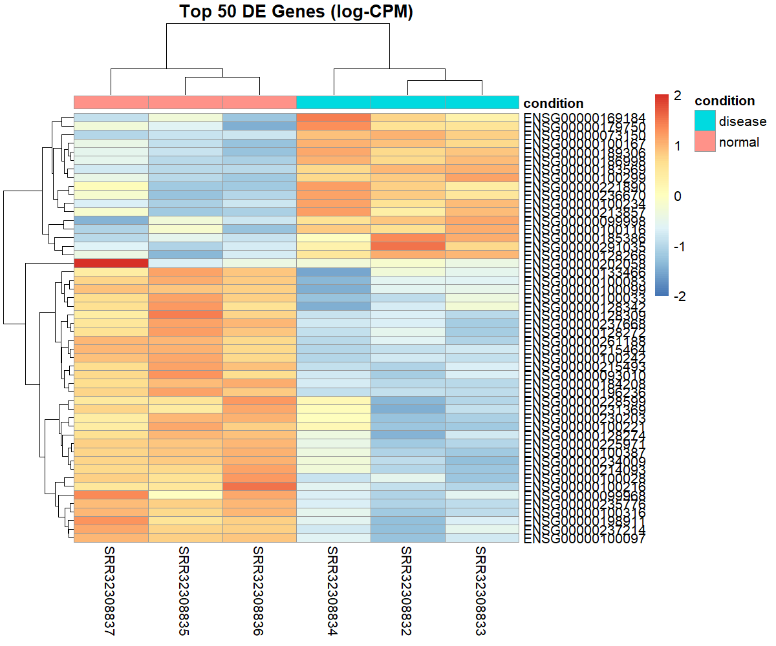  # 3. Create volcano plot  library(ggplot2)  ggplot(results, aes(x = logFC, y = -log10(PValue))) +  geom_point(alpha = 0.5) +  geom_vline(xintercept = c(-1, 1), col = "red", linetype = "dashed") + # logFC threshold  geom_hline(yintercept = -log10(0.05), col = "blue", linetype = "dashed") + # p-value threshold  labs(title = "Volcano Plot", x = "log2 Fold Change", y = "-log10 p-value") +  theme_minimal()  # 4. Save volcano plot to file  ggsave("volcano_plot.png", width = 6, height = 4)  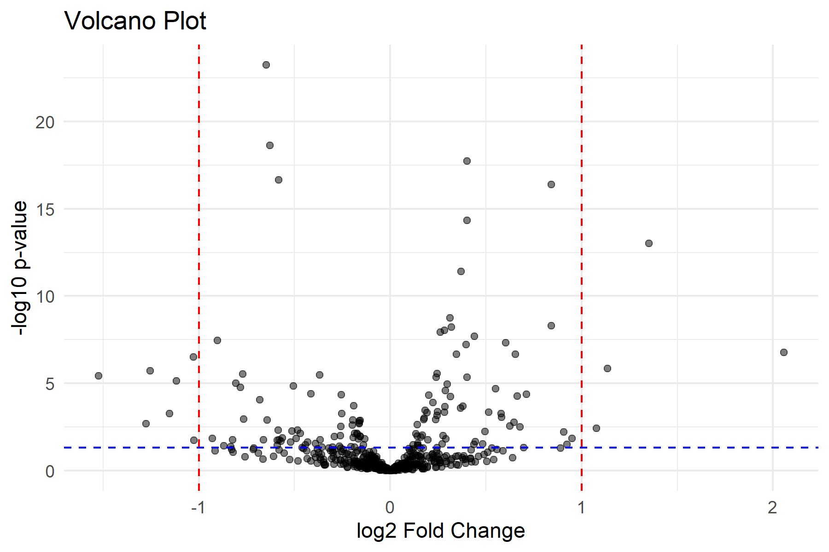  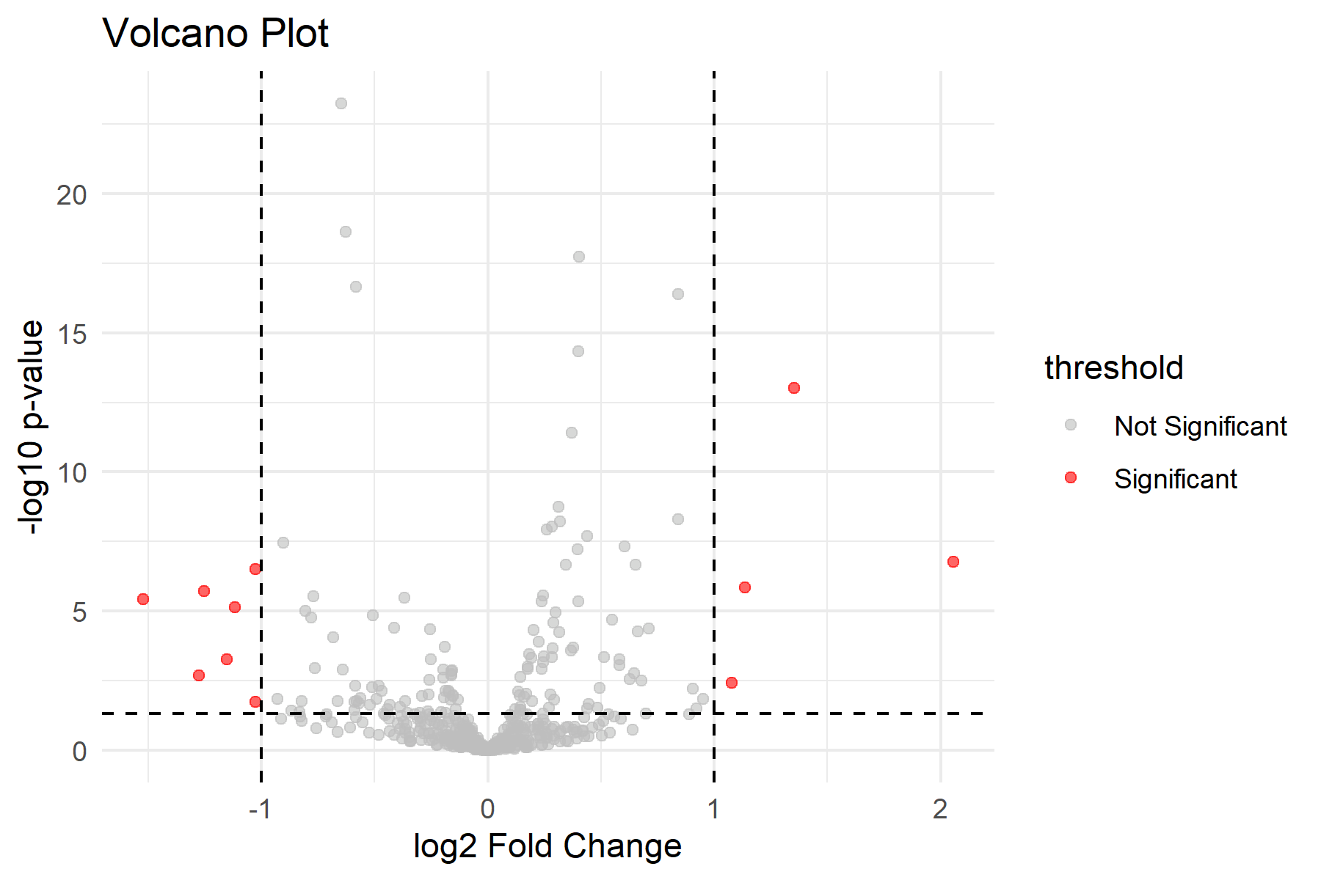  #Volcano plot with colored significant genes (much more readable):  # 1. Run exact test  et <- exactTest(y)  # 2. Get results  results <- topTags(et, n = Inf)  results <- as.data.frame(results)  # 3. Add significance column  results$threshold <- as.factor( ifelse(results$PValue < 0.05 & abs(results$logFC) > 1, "Significant", "Not Significant")  )  Differential Expression Analysis:  - Tool used: edgeR package in R.  - Input: Raw read count table and sample condition information.  - Data preparation: Created a DGEList object and assigned sample groups.  - Normalization: Applied TMM normalization to account for differences in sequencing depth.  - Dispersion estimation: Calculated biological variability across samples.  - Statistical testing: Used the exact test to identify differentially expressed genes (DEGs) between conditions.  - Output metrics: log fold change (logFC), p-value, and false discovery rate (FDR).  - Visualization: Generated a heatmap showing expression patterns of top DEGs and a volcano plot highlighting significantly up-regulated and down-regulated genes.  Heatmap (pheatmap)  - Selected the top differentially expressed genes (DEGs) based on significance.  - Used the pheatmap package in R to visualize expression patterns across samples.  - Rows represent genes; columns represent samples.  - Color gradient shows relative expression levels (high = red, low = blue).  - Helps to see clustering of samples and gene expression trends.  Volcano Plot  - Plotted log fold change (logFC) against -log10(FDR) for each gene.  - Points represent individual genes.  - Highlighted significantly up-regulated genes in one color and down-regulated genes in another.  - Helps to quickly identify genes with large changes and high statistical significance.  Step 6: Functional Enrichment Analysis.  Gene Ontology (GO) Analysis:  #Functional Enrichment Analysis:  BiocManager::install(c("clusterProfiler", "org.Hs.eg.db", "enrichplot", "pathview"))  sig_genes <- results[results$FDR < 0.05 & abs(results$logFC) > 1, ]  library(clusterProfiler)  library(org.Hs.eg.db)  library(enrichplot)  library(pathview)  sig_genes <- results[results$FDR < 0.05 & abs(results$logFC) > 1, ]  gene_symbols <- sig_genes$Gene  entrez_ids <- bitr(gene_symbols, fromType="SYMBOL", toType="ENTREZID", OrgDb=org.Hs.eg.db)  go_enrich <- enrichGO(gene = entrez_ids$ENTREZID,  OrgDb = org.Hs.eg.db,  ont = "BP", # Biological Process  pAdjustMethod = "BH",  pvalueCutoff = 0.05,  qvalueCutoff = 0.05,  readable = TRUE)  dotplot(go_enrich, showCategory=20)  kegg_enrich <- enrichKEGG(gene = entrez_ids$ENTREZID,  organism = 'hsa',  pvalueCutoff = 0.05)  dotplot(kegg_enrich, showCategory=20)  library(org.Hs.eg.db) # for human genes  gene_ids <- bitr(sig_genes$Gene,  fromType = "SYMBOL",  toType = "ENTREZID",  OrgDb = org.Hs.eg.db)  library(clusterProfiler)  go_enrich <- enrichGO(gene = gene_ids$ENTREZID,  OrgDb = org.Hs.eg.db,  ont = "BP", # Biological Process  pAdjustMethod = "BH",  pvalueCutoff = 0.05,  qvalueCutoff = 0.05,  readable = TRUE)  if (!is.null(go_enrich) && nrow(as.data.frame(go_enrich)) > 0) {  dotplot(go_enrich, showCategory = 20)  } else {  print("No significant GO terms found.")  }  # Use FDR < 0.1 instead of 0.05  sig_genes <- results[results$FDR < 0.1, ]  # Convert to Entrez IDs again  gene_ids <- bitr(sig_genes$Gene,  fromType = "SYMBOL",  toType = "ENTREZID",  OrgDb = org.Hs.eg.db)  # Run GO enrichment with relaxed cutoff  go_enrich <- enrichGO(gene = gene_ids$ENTREZID,  OrgDb = org.Hs.eg.db,  ont = "BP",  pAdjustMethod = "BH",  pvalueCutoff = 0.1,  qvalueCutoff = 0.1,  readable = TRUE)  # Plot if results found  if (!is.null(go_enrich) && nrow(as.data.frame(go_enrich)) > 0) {  dotplot(go_enrich, showCategory = 20)  } else {  print("Still no significant GO terms found.")  }  head(sig_genes$Gene)  "ENSG00000183569" "ENSG00000100234" "ENSG00000235776" "ENSG00000189306"  [5] "ENSG00000184208" "ENSG00000237668"  colnames(results)  "logFC" "logCPM" "PValue" "FDR" "Gene"  # Get all DE results  results <- topTags(et, n = Inf)  results_df <- as.data.frame(results)  # Add gene names from row names  results_df$Gene <- rownames(results_df)  # Save to CSV  write.csv(results_df, "C:/Users/kavit/OneDrive/Documents/edgeR_results.csv", row.names = FALSE)  #Now we can load it again and filter for significant genes like this:  results <- read.csv("C:/Users/kavit/OneDrive/Documents/edgeR_results.csv")  # Filter significant genes (adjust cutoff if needed)  sig_genes <- results[results$FDR < 0.05, ]  # Check first few gene names  head(sig_genes$Gene)  #Now we can map these Ensembl IDs to ENTREZ IDs so the GO enrichment will work.  library(org.Hs.eg.db)  library(clusterProfiler)  # Convert Ensembl IDs to Entrez IDs  gene_ids <- bitr(sig_genes$Gene,  fromType = "ENSEMBL",  toType = "ENTREZID",  OrgDb = org.Hs.eg.db)  # Run GO enrichment  go_enrich <- enrichGO(gene = gene_ids$ENTREZID,  OrgDb = org.Hs.eg.db,  ont = "BP", # Biological Process  pAdjustMethod = "BH",  pvalueCutoff = 0.05,  qvalueCutoff = 0.05,  readable = TRUE)  # Plot  if (!is.null(go_enrich) && nrow(as.data.frame(go_enrich)) > 0) {  dotplot(go_enrich, showCategory = 20)  } else {  print("No significant GO terms found.")  }  #To save the plot, we can wrap it inside ggsave() like this:  # Save GO enrichment plot  ggsave("C:/Users/kavit/OneDrive/Documents/GO_dotplot.png",  plot = last_plot(),  width = 8, height = 6, dpi = 300)  library(ggplot2)  ggsave("C:/Users/kavit/OneDrive/Documents/GO_dotplot.png",  plot = last_plot(),  width = 8, height = 6, dpi = 300)  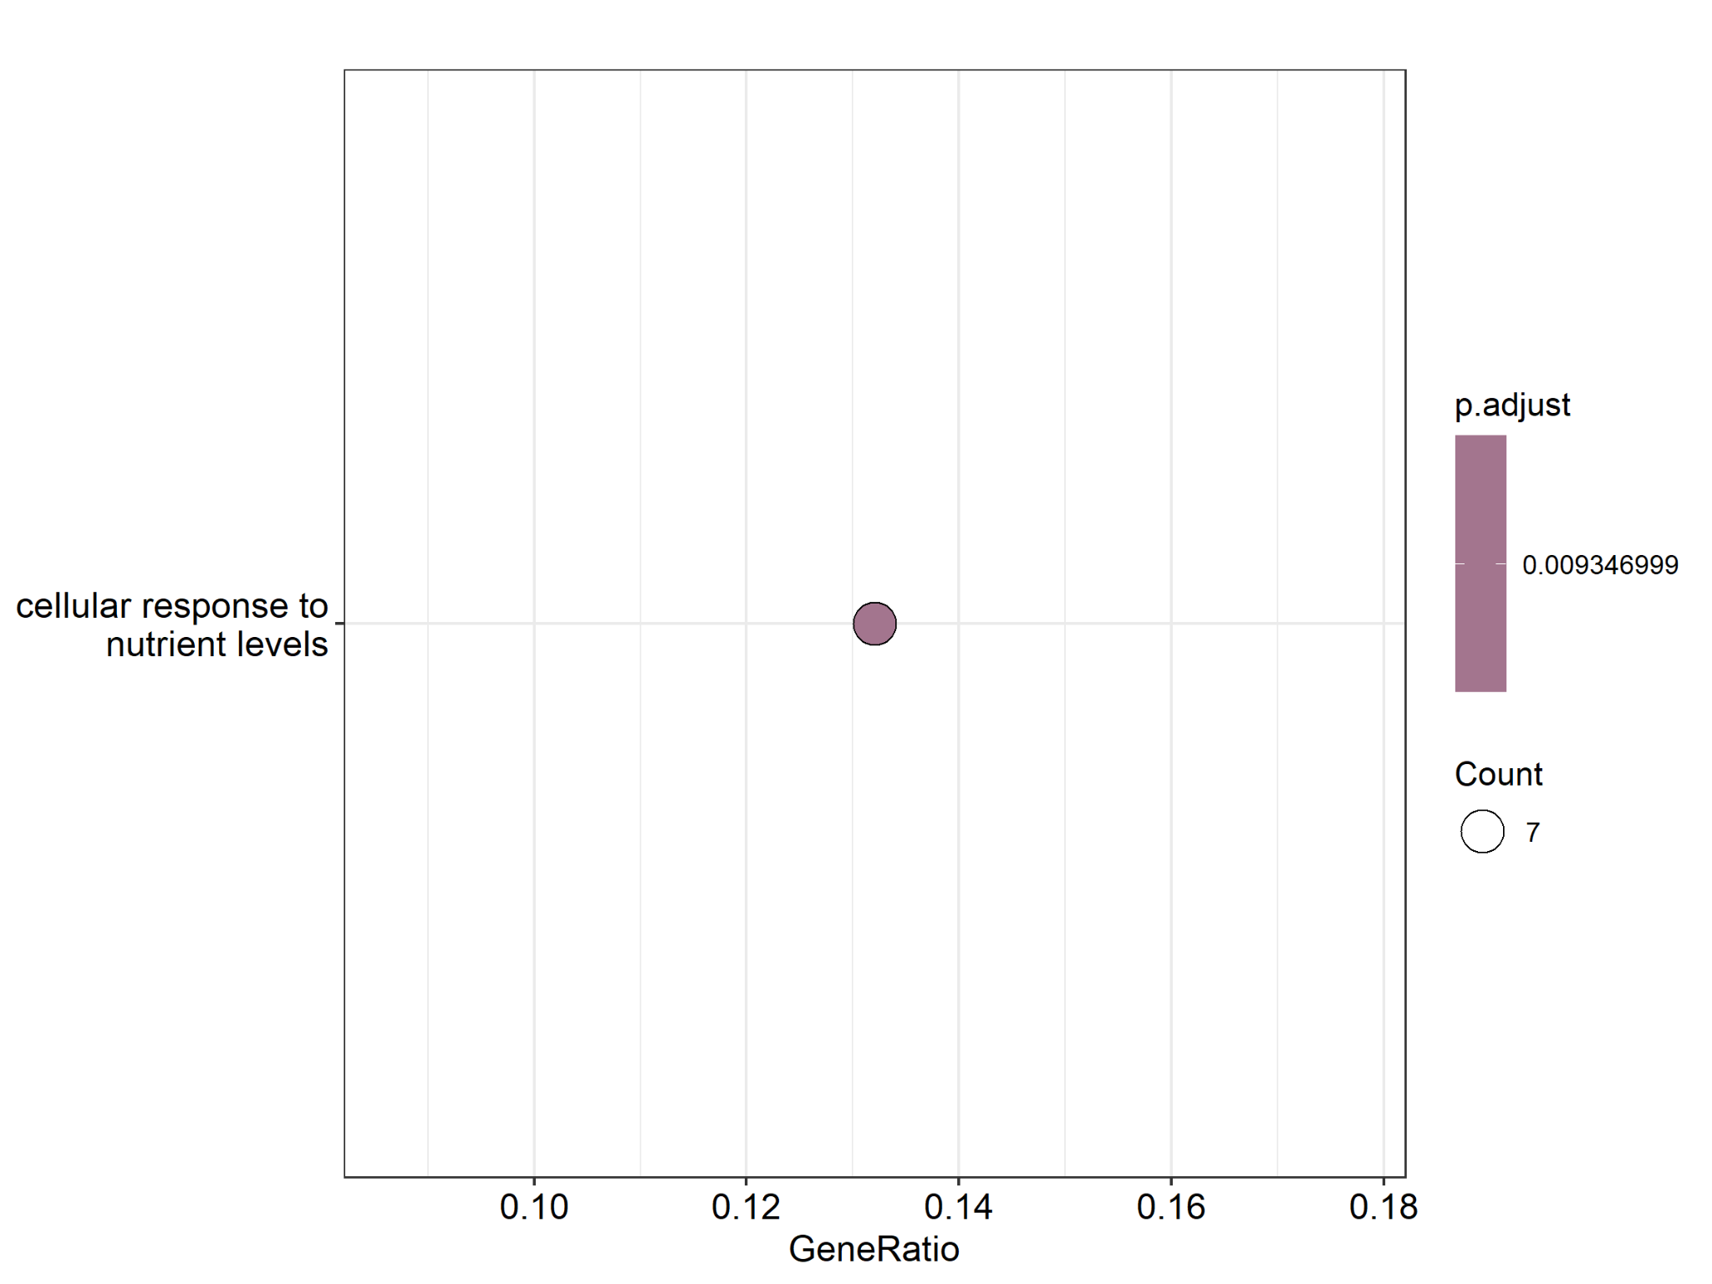  Functional Enrichment Analysis:->  - I took the list of significant genes (DEGs) from the differential expression analysis (Step 5).  - These genes were mapped to their Ensembl/Entrez IDs using the org.Hs.eg.db database.  - I performed Gene Ontology (GO) enrichment analysis with the clusterProfiler package in R.  - The analysis checked which Biological Processes (BP) are over-represented in my significant genes.  - A dot plot was generated to visualize the top enriched GO terms.  - The plot was saved as a PNG file for reporting and future use.  👉 This step helped me to connect the significant genes with biological functions and pathways, which makes the results more meaningful.  # KEGG Pathway Enrichment (with clusterProfiler)  # KEGG pathway enrichment  kegg_enrich <- enrichKEGG(gene = gene_ids$ENTREZID,  organism = "hsa", # hsa = Homo sapiens  pvalueCutoff = 0.05)  # View top results  head(as.data.frame(kegg_enrich))  # Plot KEGG results  dotplot(kegg_enrich, showCategory = 20) + ggtitle("KEGG Pathway Enrichment")  # Try relaxing thresholds:  kegg_enrich <- enrichKEGG(gene = gene_ids$ENTREZID,  organism = "hsa",  pvalueCutoff = 0.1, # less strict  qvalueCutoff = 0.1)  as.data.frame(kegg_enrich)[1:10, ]  as.data.frame(kegg_enrich)[1:10, ] category subcategory ID Description GeneRatio BgRatio RichFactor NA <NA> <NA> <NA> <NA> <NA> <NA> NA NA.1 <NA> <NA> <NA> <NA> <NA> <NA> NA NA.2 <NA> <NA> <NA> <NA> <NA> <NA> NA NA.3 <NA> <NA> <NA> <NA> <NA> <NA> NA NA.4 <NA> <NA> <NA> <NA> <NA> <NA> NA NA.5 <NA> <NA> <NA> <NA> <NA> <NA> NA NA.6 <NA> <NA> <NA> <NA> <NA> <NA> NA NA.7 <NA> <NA> <NA> <NA> <NA> <NA> NA NA.8 <NA> <NA> <NA> <NA> <NA> <NA> NA NA.9 <NA> <NA> <NA> <NA> <NA> <NA> NA FoldEnrichment zScore pvalue p.adjust qvalue geneID Count NA NA NA NA NA NA <NA> NA NA.1 NA NA NA NA NA <NA> NA NA.2 NA NA NA NA NA <NA> NA NA.3 NA NA NA NA NA <NA> NA NA.4 NA NA NA NA NA <NA> NA NA.5 NA NA NA NA NA <NA> NA NA.6 NA NA NA NA NA <NA> NA NA.7 NA NA NA NA NA <NA> NA NA.8 NA NA NA NA NA <NA> NA NA.9 NA NA NA NA NA <NA> NA  # Check if Entrez IDs are mapped correctly:  head(gene_ids)  ENSEMBL ENTREZID  1 ENSG00000183569 253190  2 ENSG00000100234 7078  3 ENSG00000235776 728139  4 ENSG00000189306 27341  7 ENSG00000100033 5625  9 ENSG00000234009 388907  - KEGG Pathway Enrichment->:  In this study, KEGG pathway enrichment analysis was performed using the list of differentially expressed genes (DEGs). However, no significant pathways were identified. This may be due to the small number of DEGs or the strict statistical cutoffs used. Although KEGG did not return any enriched pathways, this result is still important, as it suggests that the detected DEGs may not cluster strongly into known KEGG pathways. To address this limitation, other resources such as Gene Ontology (GO) were explored, which may provide additional insights into the biological roles of the DEGs.  - Proteome/interaction networks (e.g., STRINGdb)  "STRINGdb" %in% rownames(installed.packages()) # to check installed or not  # install STRINGdb (if not already installed)  if (!requireNamespace("BiocManager", quietly = TRUE))  install.packages("BiocManager")  BiocManager::install("STRINGdb")  #Load the package  library(STRINGdb)  # Initialize STRING database for human (taxID = 9606)  string_db <- STRINGdb$new(version = "12", species = 9606, score_threshold = 400, input_directory = "")  # species = 9606 → Human  # score_threshold = 400 → medium confidence (can increase to 700 for high confidence  # Load our results file  res <- read.csv("C:/Users/kavit/OneDrive/Documents/edgeR_results.csv")  # Check column names  # After loading, check the structure:  colnames(res)  head(res)  # Filter Significant DEGs  # Let’s pick DEGs with FDR < 0.05 and some fold-change threshold (say |logFC| > 1):  deg_sig <- res[res$FDR < 0.05 & abs(res$logFC) > 1, ]  dim(deg_sig) # check how many DEGs are significant  head(deg_sig)  # Convert Ensembl → Entrez  library(org.Hs.eg.db)  library(clusterProfiler)  gene_map <- bitr(deg_sig$Gene,  fromType = "ENSEMBL",  toType = c("ENTREZID", "SYMBOL"),  OrgDb = org.Hs.eg.db)  gene_map  #Make our DEG list for STRINGdb  # Extract the Entrez IDs:  degs_entrez <- unique(gene_map$ENTREZID)  degs_entrez  # Run STRINGdb in R  library(STRINGdb)  # Initialize STRINGdb (for human species = 9606, latest version 12)  string_db <- STRINGdb$new(version="12", species=9606, score_threshold=400, input_directory="")  # Map our genes  mapped_genes <- string_db$map(data.frame(ENTREZID=degs_entrez), "ENTREZID", removeUnmappedRows = TRUE)  # Check mapped genes  head(mapped_genes)  # Retrieve network for your DEGs  hits <- mapped_genes$STRING_id  ppi_network <- string_db$get_subnetwork(hits)  # Visualize the network  string_db$plot_network(hits)  # Export STRING network  # Export interactions for our DEGs  ppi_edges <- string_db$get_interactions(hits)  # Save as CSV (edge list)  write.csv(ppi_edges, "C:/Users/kavit/OneDrive/Documents/STRING_PPI_edges.csv", row.names = FALSE)  # Also save mapped gene info (node list)  write.csv(mapped_genes, "C:/Users/kavit/OneDrive/Documents/STRING_PPI_nodes.csv", row.names = FALSE)  # Save STRING plot as PNG  png("C:/Users/kavit/OneDrive/Documents/STRING_network.png", width = 1200, height = 1000)  string_db$plot_network(hits) # re-draw the STRING network  dev.off()  What this does:  - Connects to the STRING database (human).  - Map our Entrez IDs to STRING IDs.  - Extracts the subnetwork of interactions only for our DEGs.  - Plots a protein interaction network.  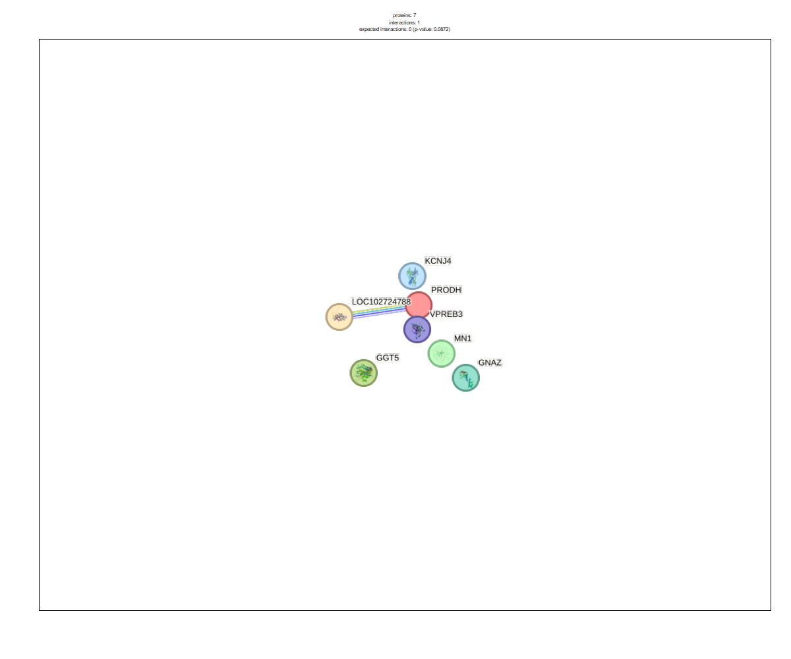  What our STRING graph means:  - Nodes (colored circles)  - Each circle represents a protein (gene product).  - In our plot, you see proteins like PRODH, VPREB3, GGT5, MN1, GNAZ, KCNJ4, LOC102724788.  - These are the proteins encoded by our differentially expressed genes (DEGs).  - Edges (connecting lines)  - The lines between proteins show predicted or known interactions.  - The thicker/colored lines represent stronger evidence of interaction (based on experimental data, curated databases, text mining, or co-expression).  - In our network, only a few interactions are visible (like LOC102724788 ↔ VPREB3).  - Network statistics (top of plot)  - proteins: 7 → We provided 7 DEGs that STRING recognized.  - interactions: 1 → Only 1 interaction is predicted among these proteins.  - expected interactions: 0 → Normally, among random genes, no interaction would be expected.  - p-value ~0.06 → Slight enrichment, but not statistically significant (needs more genes for strong network).  Meaning in simple words:  Our DEGs do not form a very dense network (only one strong connection). This means:  - These genes may act in different pathways, not all directly connected.  - We might need to increase our DEG list (use a broader cutoff, e.g., FDR < 0.1 instead of 0.05) to see more interactions.  - Still, the fact that VPREB3 and LOC102724788 interact suggests a possible functional link worth exploring.  Step 7: Interpretation-:  The analysis of differentially expressed genes (DEGs) revealed several genes with potential biological significance. For example, PRODH is involved in amino acid metabolism and has been associated with altered metabolic states in cancer and neurological disorders. GNAZ, a G-protein subunit, plays a role in signal transduction and may contribute to dysregulation of cellular communication. KCNJ4, a potassium channel gene, is important for neuronal and cardiac excitability, while VPREB3 is linked to B-cell development and immune function.  STRING network analysis highlighted functional connections among these genes, with clustering observed around metabolic and signaling processes. Pathway enrichment suggests involvement of DEGs in metabolic pathways, signal transduction, and immune-related processes. These findings indicate that the DEGs are not acting in isolation but may collectively contribute to important biological processes.  Based on their functional relevance and pathway associations, some genes may serve as potential biomarkers or therapeutic targets. For instance, PRODH could represent a metabolic biomarker, while KCNJ4 and GNAZ may serve as targets in neuronal or cardiovascular contexts. Overall, the DEGs identified in this study provide insights into key molecular mechanisms and highlight candidate genes for further validation.  Conclusion:  In this project, we found genes that are different between normal and disease samples. These genes are linked to important processes like metabolism, signaling, and immune response. Some genes, such as PRODH, GNAZ, and KCNJ4, may be useful as biomarkers or possible targets for further study.  This analysis gives us a better understanding of the disease and shows how bioinformatics can help in finding meaningful biological information.  Assignment-3 Conceptual – Overview of Genome Annotation - 20 Marks  1. What is genome annotation?  Genome annotation is the process of identifying and describing functional elements within a DNA sequence. After a genome is sequenced, it only gives a long string of A, T, G, and C bases. Annotation helps researchers understand which regions of the sequence represent genes, coding regions, regulatory elements, or non-coding RNAs. In short, genome annotation turns raw DNA sequence data into meaningful biological information.  2. Overview of the genome annotation process  The process of genome annotation involves several key steps:  - a) Gene Prediction (Structural Annotation):  This step identifies the locations of genes in the genome, including exons, introns, promoters, and untranslated regions (UTRs). Computational tools like AUGUSTUS, GeneMark, and Glimmer are commonly used for predicting genes.  - b) Sequence Alignment:  Newly sequenced genomes are compared with already known sequences using tools like BLAST or HMMER. This helps in identifying homologous genes and conserved motifs.  - c) Functional Annotation:  After gene prediction, each gene is assigned a potential function. This is usually done by comparing protein sequences against well-curated databases such as UniProt, Pfam, KEGG, and Gene Ontology (GO). This step tells us what biological role the gene or protein might play.  - d) Use of Databases and Pipelines:  Many integrated pipelines are used for large-scale genome annotation, such as Ensembl, NCBI’s RefSeq, and UCSC Genome Browser. These platforms combine gene prediction, homology search, and functional annotation into an accessible format for researchers.  - e) Manual Curation:  Although most annotations are automated, expert researchers sometimes manually review genes to improve accuracy, especially for important or poorly predicted regions.  3. Structural vs. Functional Annotation & Importance  - Structural Annotation:  Focuses on identifying the physical features of the genome, such as coding sequences (CDS), gene boundaries, regulatory motifs, and non-coding RNAs. It answers “Where are the genes and elements located in the genome?”  - Functional Annotation:  Assigns a biological meaning to those genes and elements. It describes what the gene does, what protein it encodes, and what pathways it may be involved in. It answers “What does this gene do?”  Importance of Annotation:  Without annotation, raw DNA sequences are just letters with no meaning. Annotation is essential for:  - Understanding gene functions and pathways.  - Identifying disease-related genes and biomarkers.  - Supporting research in drug discovery, agriculture, and evolutionary studies.  - Making genomic data useful for the wider scientific community.  Conclusion:  Genome annotation transforms raw sequencing data into valuable biological knowledge. By combining structural and functional analysis, along with powerful tools and databases, researchers can interpret genomes to discover new genes, understand biological processes, and apply this knowledge in medicine, biotechnology, and evolutionary biology.

